**CAR DEKHO PROJECT – MYSQL**

1. **Total Cars: To get Count of total records**

select count(*) from cars. car_dekho;

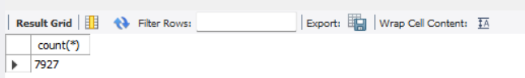

1. **Number of cars available in the year 2023**

Select count(*) from cars.car_dekho where year=2023;

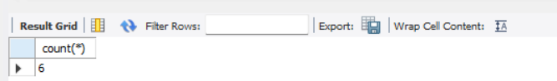

1. **Number of cars available in the year 2020,2021,2022**

select year, count(*) from cars.car_dekho where year in(2020,2021,2022)

group by year;

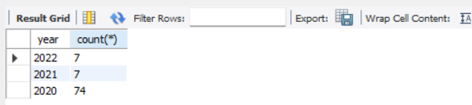

1. **Total of all cars by year**

select year, count(*) from cars.car_dekh group by year;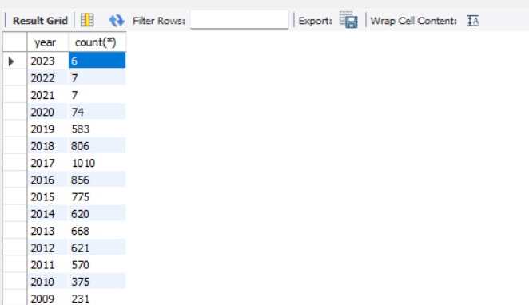o

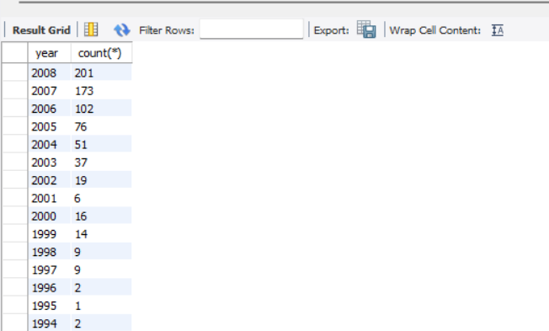

1. **Number of diesel cars in the year 2020**

select Fuel,Year,count(*) from cars.car_dekho where Fuel='Diesel' and year=2020;

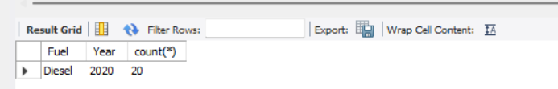

1. **Number of petrol cars in the year 2020**

select Fuel,Year,count(*) from cars.car_dekho where Fuel='Petrol' and year=2020;



1. **print all fuel cars(Petrol, Diesel, CNG) come by all year**

select year,count(*) from cars.car_dekho where fuel in("Petrol","Diesel","CNG")group by year;

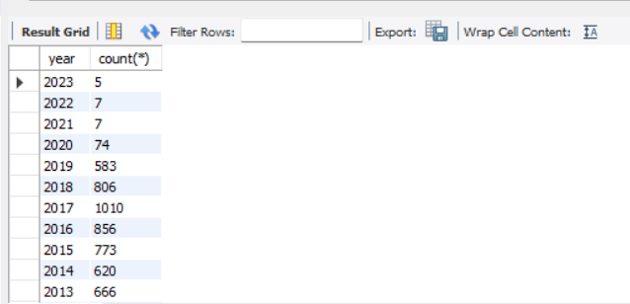

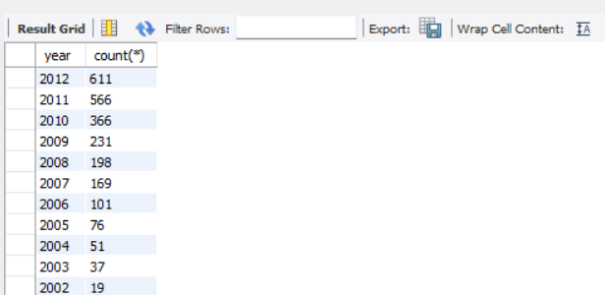

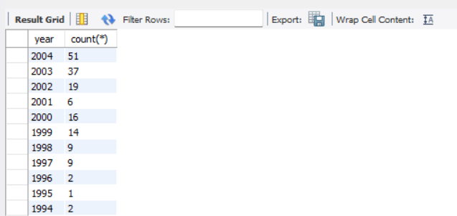

1. **Which year had more than 100 cars**

select year, count(*) from cars.car_dekho group by year having count(*)>100;

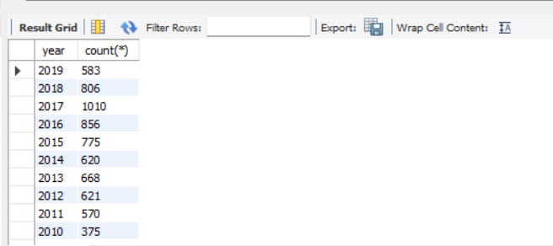



1. **count of cars between 2015 and 2023**

select count(*) from cars.car_dekho where year between 2015 and 2023;

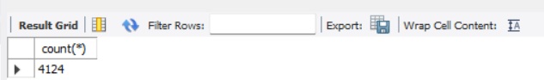

1. **car details between 2015 and 2023**

select * from cars.car_dekho where year between 2015 and 2023;

